Looking after your personal information

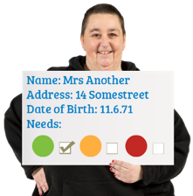 | We ‘Anchor’ hold personal information about the people we provide services to.
We use this information to:

- understand your care and support needs
- give you the right information
- arrange services to meet your care and support needs
- understand if you or other people are at risk of abuse. And do something about it.
 | We might not be able to give you a service unless we have the right information.
 | We will only share personal information if it is legal to do so.

We store personal information securely.

We try to make sure the information is right.

We only keep the information for as long as it is needed.
What does this information include?

- It includes personal details

- And which services are given.
You can ask to see your information. Email: fran@anchorsupport.org
To find out more you can read our privacy policy on our website.

Or you can contact Fran Parkinson

Email: fran@anchorsupport.org

